US History and Immigration

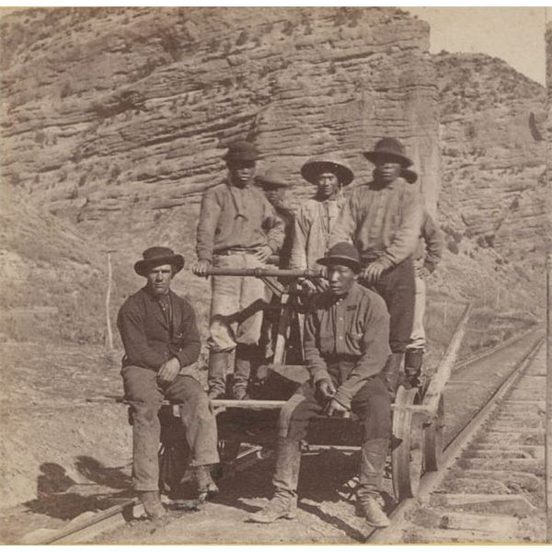
The 19th Century: 15 Million Immigrants

Between the 1820s and the 1880s, over 15 million immigrants came to the U.S., mostly from Europe. If they did not go to the Midwest to farm the land, they usually stayed in the Northeast and worked in the factories and textile mills of the Northeast. On the West Coast, Irish and Chinese immigrants were an important source of labour for the Transcontinental Railroad, helping contribute to westward expansion and America developing a global economy. The U.S. began to see some people express anti-immigrant feelings, especially from the Protestant Americans against the Catholic immigrants from Ireland. The U.S. also passed the 1882 Chinese Exclusion Act, the only immigration law in U.S. history that excluded a single group from immigration and citizenship.

The 20th Century: Ellis Island
Ellis Island played an important role in U.S. history and immigration. Between 1892 and 1954, more than 12 million immigrants entered New York Harbor, passing by the Statue of Liberty on their way to the immigration processing station on Ellis Island. Immigrants were required to pass a medical exam and show legal documents confirming their identity. Immigrants who were ill but could be cured were sent to the hospital, but people who were contagious or had any other condition that made it impossible to work were sent back home. Many immigrants stayed in New York, working in factories, starting their own businesses and developing neighbourhoods that reminded them of home. Some of the famous people who went through Ellis Island include Sigmund Freud, actor Charlie Chaplin, composer Irving Berlin and entertainer Bob Hope.

Bright Hub Education. (n.d.). U.S. History and Immigration Facts and Study Guide. Retrieved from https://www.brighthubeducation.com/history-homework-help/107041-us-history-and-immigration/

